**1]Write an ALP to implement bubble sort**

**INPUT –**

%macro print 2

    push eax

    push ebx

    push ecx

    mov eax, 4

    mov ebx, 1

    mov ecx, %1

    mov edx, %2

    int 0x80

    pop ecx

    pop ebx

    pop eax

%endmacro

%macro exit 0

    mov eax, 1

    xor ebx, ebx

    int 0x80

%endmacro

section .data

    prompt_size db "Enter number of elements: ", 0

    prompt_element db "Enter element: ", 0

    msg_iteration db "Iteration ", 0

    msg_array db "Array: ", 0

    msg_complete db "Bubble sort executed", 10, 0

    msg_sorted db "Sorted array: ", 0

    newline db 10, 0

    space db " ", 0

    minus db "-", 0

section .bss

    array resd 100

    size resd 1

    buffer resb 12

    negative resb 1

    swapped resb 1

section .text

global _start

_start:

    print prompt_size, 25

    call read_int

    mov [size], eax

    xor ebx, ebx

input_loop:

    cmp ebx, [size]

    jge input_done

    print prompt_element, 15

    call read_int

    mov [array + ebx*4], eax

    inc ebx

    jmp input_loop

input_done:

    print newline, 1

    mov ecx, [size]

    dec ecx

    jle sort_done

bubble_sort:

    mov byte [swapped], 0

    xor ebx, ebx

inner_loop:

    mov eax, [array + ebx*4]

    cmp eax, [array + ebx*4 + 4]

    jle no_swap

    xchg eax, [array + ebx*4 + 4]

    mov [array + ebx*4], eax

    mov byte [swapped], 1

no_swap:

    inc ebx

    cmp ebx, ecx

    jl inner_loop

    push ecx

    print newline, 1

    print msg_iteration, 10

    mov eax, [size]

    sub eax, ecx

    call print_int

    print newline, 1

    print msg_array, 7

    call print_array

    print newline, 1

    pop ecx

    dec ecx

    cmp byte [swapped], 0

    jne bubble_sort

sort_done:

    print newline, 1

    print msg_complete, 19

    print newline, 1

    print msg_sorted, 14

    call print_array

    print newline, 1

    exit

read_int:

    push ebx

    push ecx

    push edx

    push esi

    mov eax, 3

    mov ebx, 0

    mov ecx, buffer

    mov edx, 12

    int 0x80

    mov byte [negative], 0

    mov esi, buffer

    xor eax, eax

    xor ebx, ebx

    mov bl, [esi]

    cmp bl, '-'

    jne convert_start

    mov byte [negative], 1

    inc esi

convert_start:

    movzx edx, byte [esi]

    inc esi

    cmp dl, 10

    je convert_done

    cmp dl, '0'

    jb convert_start

    cmp dl, '9'

    ja convert_start

    sub dl, '0'

    imul eax, 10

    add eax, edx

    jmp convert_start

convert_done:

    cmp byte [negative], 1

    jne positive_num

    neg eax

positive_num:

    pop esi

    pop edx

    pop ecx

    pop ebx

    ret

print_int:

    push eax

    push ebx

    push ecx

    push edx

    push esi

    push edi

    test eax, eax

    jns non_negative

    push eax

    print minus, 1

    pop eax

    neg eax

non_negative:

    mov ecx, 10

    mov edi, buffer

    add edi, 11

    mov byte [edi], 0

    mov esi, edi

    test eax, eax

    jnz digit_loop

    dec edi

    mov byte [edi], '0'

    jmp print_num

digit_loop:

    dec edi

    xor edx, edx

    div ecx

    add dl, '0'

    mov [edi], dl

    test eax, eax

    jnz digit_loop

print_num:

    mov ecx, edi

    mov edx, esi

    sub edx, edi

    mov eax, 4

    mov ebx, 1

    int 0x80

print_int_done:

    pop edi

    pop esi

    pop edx

    pop ecx

    pop ebx

    pop eax

    ret

print_array:

    push eax

    push ebx

    push ecx

    xor ebx, ebx

print_loop:

    cmp ebx, [size]

    jge print_done

    mov eax, [array + ebx*4]

    call print_int

    print space, 1

    inc ebx

    jmp print_loop

print_done:

    pop ecx

    pop ebx

    pop eax

    ret

**OUTPUT –**

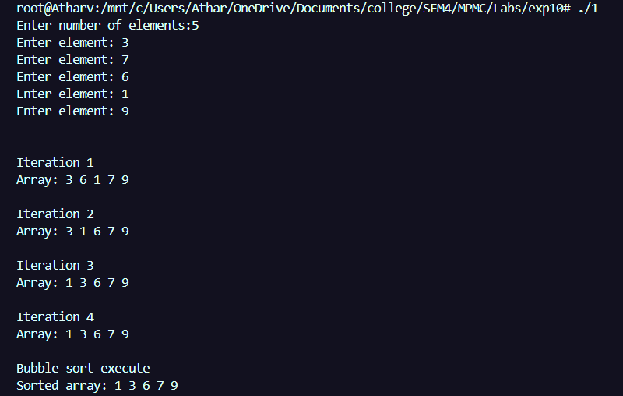

**2]Write an ALP to implement insertion sort**

**INPUT –**

%macro print 2

    push eax

    push ebx

    push ecx

    mov eax, 4

    mov ebx, 1

    mov ecx, %1

    mov edx, %2

    int 0x80

    pop ecx

    pop ebx

    pop eax

%endmacro

%macro exit 0

    mov eax, 1

    xor ebx, ebx

    int 0x80

%endmacro

section .data

    prompt_size db "Enter number of elements: ", 0

    prompt_element db "Enter element: ", 0

    msg_iteration db "Iteration ", 0

    msg_array db "Array: ", 0

    msg_complete db "Insertion sort executed", 10, 0

    msg_sorted db "Sorted array: ", 0

    newline db 10, 0

    space db " ", 0

    minus db "-", 0

section .bss

    array resd 100

    size resd 1

    buffer resb 12

    negative resb 1

    key resd 1

section .text

global _start

_start:

    print prompt_size, 25

    call read_int

    mov [size], eax

    xor ebx, ebx

input_loop:

    cmp ebx, [size]

    jge input_done

    print prompt_element, 15

    call read_int

    mov [array + ebx*4], eax

    inc ebx

    jmp input_loop

input_done:

    print newline, 1

    mov ecx, 1

insertion_sort:

    cmp ecx, [size]

    jge sort_done

    mov eax, [array + ecx*4]

    mov [key], eax

    mov ebx, ecx                *; j = i*

    dec ebx                     *; j = i-1*

    print newline, 1

    print msg_iteration, 10

    mov eax, ecx

    call print_int

    print newline, 1

    print msg_array, 7

    call print_array

    print newline, 1

while_loop:

    cmp ebx, 0                  *; while j >= 0*

    jl end_while

    mov eax, [array + ebx*4]

    cmp eax, [key]              *; and array[j] > key*

    jle end_while

    mov edx, [array + ebx*4]    *; array[j+1] = array[j]*

    mov [array + ebx*4 + 4], edx

    dec ebx                     *; j = j-1*

    jmp while_loop

end_while:

    mov eax, [key]              *; array[j+1] = key*

    mov [array + ebx*4 + 4], eax

    inc ecx                     *; i++*

    jmp insertion_sort

sort_done:

    print newline, 1

    print msg_complete, 23

    print newline, 1

    print msg_sorted, 14

    call print_array

    print newline, 1

    exit

read_int:

    push ebx

    push ecx

    push edx

    push esi

    mov eax, 3

    mov ebx, 0

    mov ecx, buffer

    mov edx, 12

    int 0x80

    mov byte [negative], 0

    mov esi, buffer

    xor eax, eax

    xor ebx, ebx

    mov bl, [esi]

    cmp bl, '-'

    jne convert_start

    mov byte [negative], 1

    inc esi

convert_start:

    movzx edx, byte [esi]

    inc esi

    cmp dl, 10

    je convert_done

    cmp dl, '0'

    jb convert_start

    cmp dl, '9'

    ja convert_start

    sub dl, '0'

    imul eax, 10

    add eax, edx

    jmp convert_start

convert_done:

    cmp byte [negative], 1

    jne positive_num

    neg eax

positive_num:

    pop esi

    pop edx

    pop ecx

    pop ebx

    ret

print_int:

    push eax

    push ebx

    push ecx

    push edx

    push esi

    push edi

    test eax, eax

    jns non_negative

    push eax

    print minus, 1

    pop eax

    neg eax

non_negative:

    mov ecx, 10

    mov edi, buffer

    add edi, 11

    mov byte [edi], 0

    mov esi, edi

    test eax, eax

    jnz digit_loop

    dec edi

    mov byte [edi], '0'

    jmp print_num

digit_loop:

    dec edi

    xor edx, edx

    div ecx

    add dl, '0'

    mov [edi], dl

    test eax, eax

    jnz digit_loop

print_num:

    mov ecx, edi

    mov edx, esi

    sub edx, ecx

    mov eax, 4

    mov ebx, 1

    int 0x80

print_int_done:

    pop edi

    pop esi

    pop edx

    pop ecx

    pop ebx

    pop eax

    ret

print_array:

    push eax

    push ebx

    push ecx

    xor ebx, ebx

print_loop:

    cmp ebx, [size]

    jge print_done

    mov eax, [array + ebx*4]

    call print_int

    print space, 1

    inc ebx

    jmp print_loop

print_done:

    pop ecx

    pop ebx

    pop eax

    ret

**OUTPUT –**

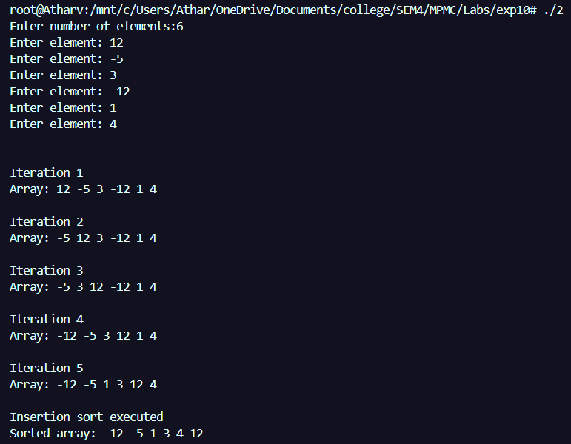

**3]Write an ALP to implement selection sort**

**INPUT –**

%macro print 2

    push eax

    push ebx

    push ecx

    mov eax, 4

    mov ebx, 1

    mov ecx, %1

    mov edx, %2

    int 0x80

    pop ecx

    pop ebx

    pop eax

%endmacro

%macro exit 0

    mov eax, 1

    xor ebx, ebx

    int 0x80

%endmacro

section .data

    prompt_size db "Enter number of elements: ", 0

    prompt_element db "Enter element: ", 0

    msg_iteration db "Iteration ", 0

    msg_array db "Array: ", 0

    msg_complete db "Selection sort executed", 10, 0

    msg_sorted db "Sorted array: ", 0

    newline db 10, 0

    space db " ", 0

    minus db "-", 0

section .bss

    array resd 100

    size resd 1

    buffer resb 12

    negative resb 1

    min_idx resd 1

section .text

global _start

_start:

    print prompt_size, 25

    call read_int

    mov [size], eax

    xor ebx, ebx

input_loop:

    cmp ebx, [size]

    jge input_done

    print prompt_element, 15

    call read_int

    mov [array + ebx*4], eax

    inc ebx

    jmp input_loop

input_done:

    print newline, 1

    mov ecx, 0

selection_sort:

    cmp ecx, [size]

    jge sort_done

    mov [min_idx], ecx

    mov ebx, ecx

    inc ebx

    print msg_iteration, 10

    mov eax, ecx

    inc eax

    call print_int

    print newline, 1

    print msg_array, 7

    print newline, 1

    call print_array

    print newline, 1

    print newline, 1

inner_loop:

    cmp ebx, [size]

    jge swap_elements

    mov eax, [array + ebx*4]

    mov edx, [min_idx]

    mov edx, [array + edx*4]

    cmp eax, edx

    jge skip_update

    mov [min_idx], ebx

skip_update:

    inc ebx

    jmp inner_loop

swap_elements:

    mov eax, [array + ecx*4]

    mov edx, [min_idx]

    mov ebx, [array + edx*4]

    mov [array + ecx*4], ebx

    mov [array + edx*4], eax

    inc ecx

    jmp selection_sort

sort_done:

    print msg_complete, 23

    print newline, 1

    print msg_sorted, 14

    call print_array

    print newline, 1

    exit

read_int:

    push ebx

    push ecx

    push edx

    push esi

    mov eax, 3

    mov ebx, 0

    mov ecx, buffer

    mov edx, 12

    int 0x80

    mov byte [negative], 0

    mov esi, buffer

    xor eax, eax

    xor ebx, ebx

    mov bl, [esi]

    cmp bl, '-'

    jne convert_start

    mov byte [negative], 1

    inc esi

convert_start:

    movzx edx, byte [esi]

    inc esi

    cmp dl, 10

    je convert_done

    cmp dl, '0'

    jb convert_start

    cmp dl, '9'

    ja convert_start

    sub dl, '0'

    imul eax, 10

    add eax, edx

    jmp convert_start

convert_done:

    cmp byte [negative], 1

    jne positive_num

    neg eax

positive_num:

    pop esi

    pop edx

    pop ecx

    pop ebx

    ret

print_int:

    push eax

    push ebx

    push ecx

    push edx

    push esi

    push edi

    test eax, eax

    jns non_negative

    push eax

    print minus, 1

    pop eax

    neg eax

non_negative:

    mov ecx, 10

    mov edi, buffer

    add edi, 11

    mov byte [edi], 0

    mov esi, edi

    test eax, eax

    jnz digit_loop

    dec edi

    mov byte [edi], '0'

    jmp print_num

digit_loop:

    dec edi

    xor edx, edx

    div ecx

    add dl, '0'

    mov [edi], dl

    test eax, eax

    jnz digit_loop

print_num:

    mov ecx, edi

    mov edx, esi

    sub edx, ecx

    mov eax, 4

    mov ebx, 1

    int 0x80

print_int_done:

    pop edi

    pop esi

    pop edx

    pop ecx

    pop ebx

    pop eax

    ret

print_array:

    push eax

    push ebx

    push ecx

    xor ebx, ebx

print_loop:

    cmp ebx, [size]

    jge print_done

    mov eax, [array + ebx*4]

    call print_int

    print space, 1

    inc ebx

    jmp print_loop

print_done:

    pop ecx

    pop ebx

    pop eax

    ret

**OUTPUT –**

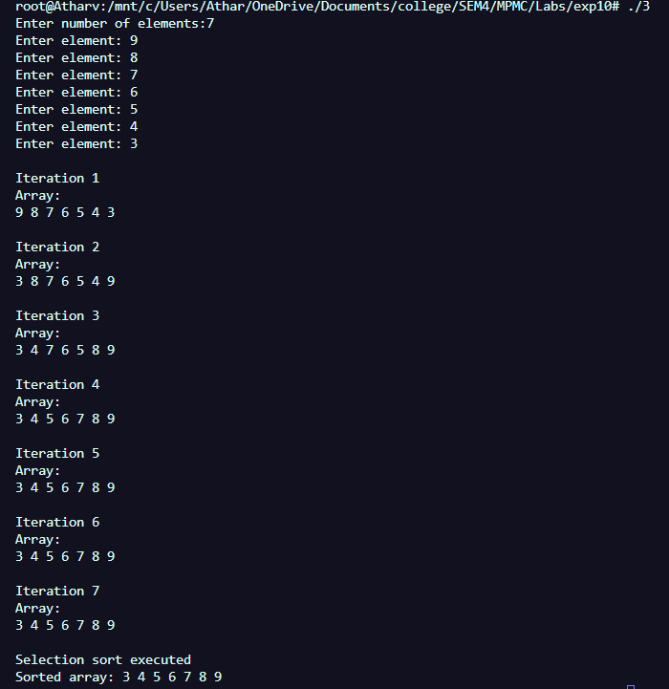

**CONCLUSION – Sorting algorithms were successfully implemented using NASM.**